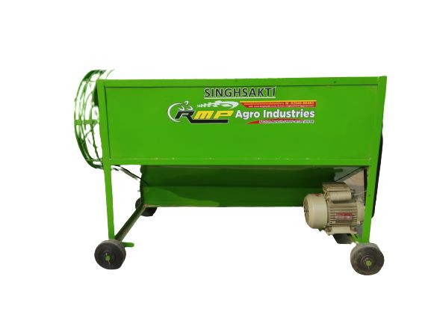 **PADDY THRESHER**

We are SINGHSAKTI, India based Supplier of **Power Operated Paddy Thresher Machine**s that are perfect outcome of modern manufacturing techniques and premium raw material. We share strong bonds with the prominent vendors who aid us completely in furnishing urgent and massive requirements of the buyers. All you need to do is place orders, timely deliveries will be at the right place.

**Specifications**

|  |  |
| --- | --- |
| Type | Power Operated |
|  |  |
| Application | Agriculture Purpose |
| Weight | 1000-2000kg |
| Automatic Grade | Semi Automatic |
| Driven Type | Hydraulic |
| Warranty | 1 Year |
| Threshing Capacity | 1000-1500kg |